# IFT 554 Middleware Prog & Database Sec

# **Module 4 Lab 1: Protecting Resources**

Name - Rituraj Gharat

Section: On-Campus Class

Prof. Dinesh Sthapit

October 17, 2024

Screenshot 1: Application is not working

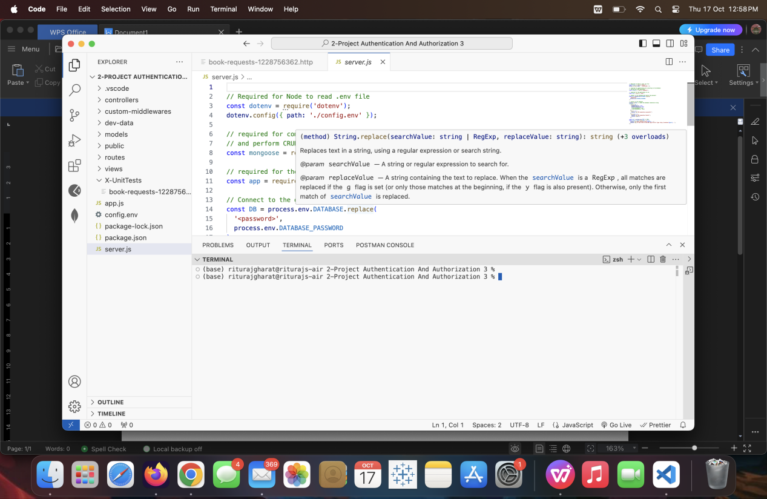

Screenshot 2: Installing Dependencies

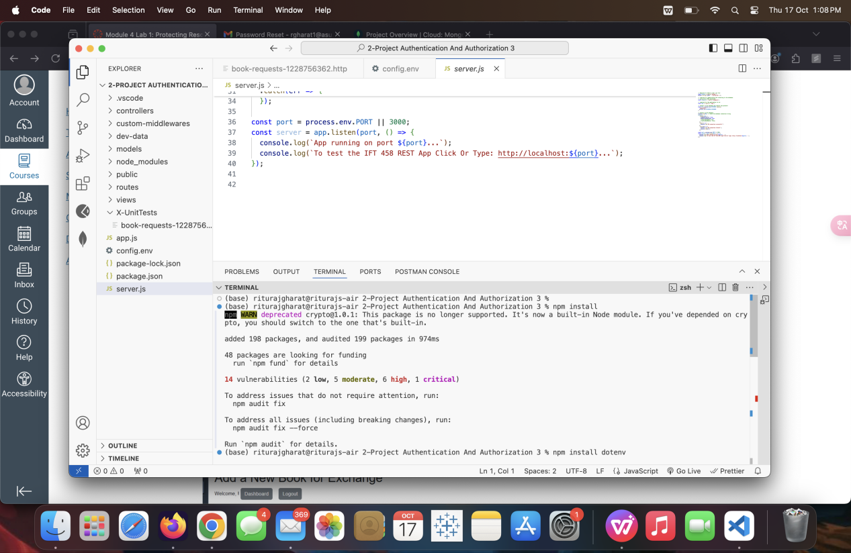

Screenshot : Installing RESTAPI

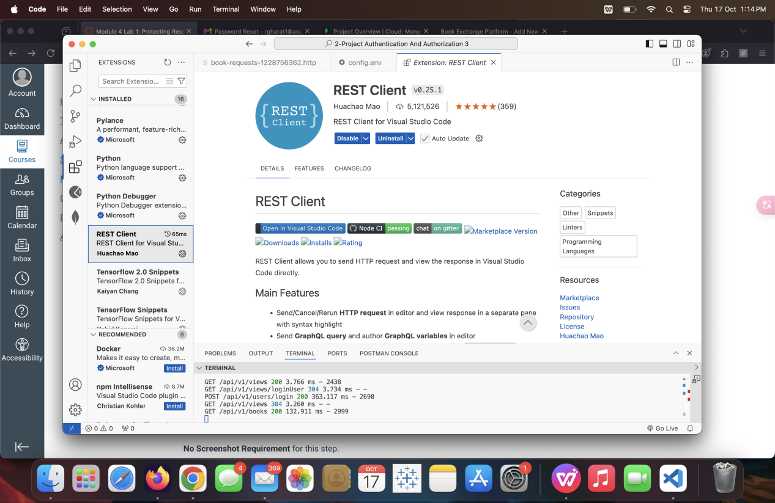

Screenshot: POST

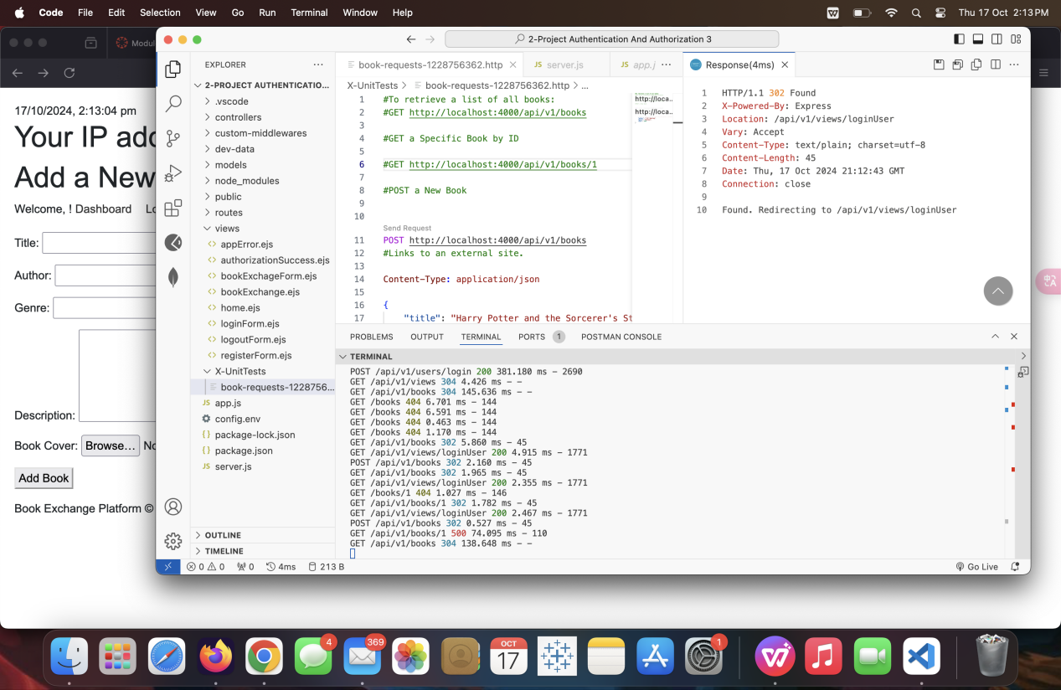

Screenshot:GET

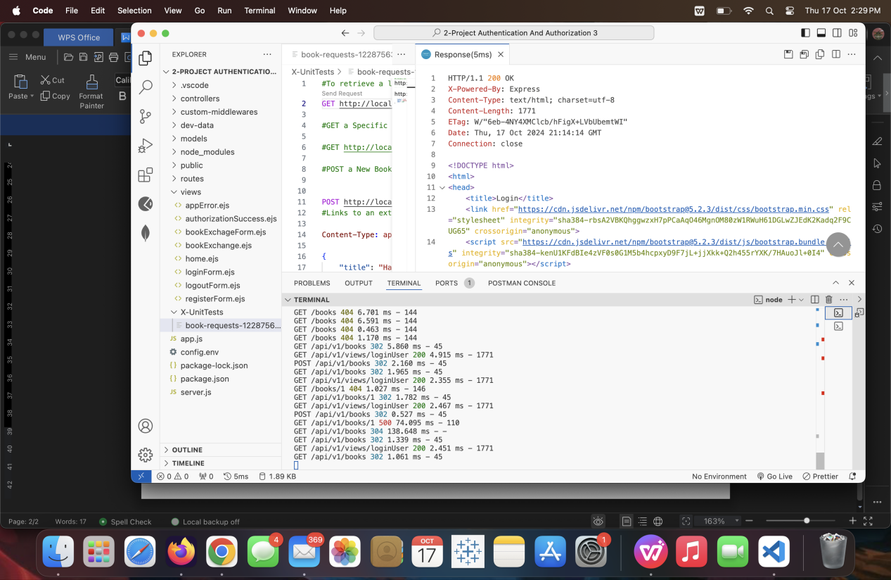

Screenshot: GET by ID

